March 8th, 2016

10:00 A.M.

OEMC 1411 W. Madison

Room 456
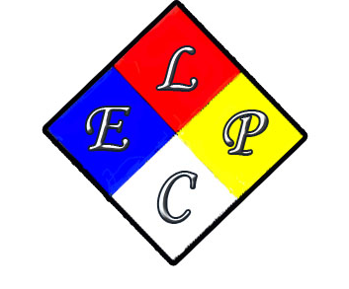

AGENDA
- Call meeting to Order ( Dan O)
- Introductions of members ( Dan O)
- Accept minutes from Dec 2015 meeting
- CERT committee update ( Dan O)
- Funding update ( Natalie)
- Update on Grant Project ( Terry )
- Website update ( Dr. Wong or Dan O )
- CFD Hazmat update ( chief Lyman)
- New business and Questions ( Dan )
Next meeting At Engine 16 Qtrs June 14th @ 10 A.M.??????? (Flag Day)

LEPC Quarterly Meeting

