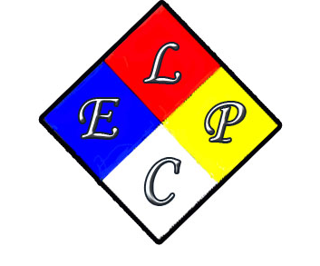

AGENDA
- Call meeting to order ( Dan O )
- Introductions ( Dan O )
- Accept minutes from June meeting ( Dan O)
- Report on Sept meeting with new director of OEMC (Dan O)
- Report on Aug 8th meeting with IEMA, Cook County and Chicago LEPC ( Dan O)
- Cook County and Chicago LEPC ( Dan O)
- IEMA update on Recognized members of Chicago LEPC. ( Jimmy Thompson )
- Discussion on the need to add a position to the Chicago LEPC ( Dan O )
- Nominations for LEPC board positions for 2017 (Dan O )
- Web site update ( Dr. Wong )
- CFD Haz-Mat update ( Chief Lyman)
- Sub-committee updates (Terry S.)
- LEPC funding update ( Natalie)
- New business & questions (Dan O)
- Next meeting Dec 13th. @ OEMC
- Adjournment...

September 13th, 2016 Rm 455

10:00 A.M.

1411 W Madison

LEPC Quarterly Meeting

