- Call meeting to Order
- Introductions
- Acceptance of Minutes September 2024
- Chicago / Cook County LEPC Exercise 2025 Recap and Improvement Planning Discussion
- USEPA Updates
- CFD HazMat update
- Committee Nominations
- New business

Thank you,
Bethany Hand
Chair

December 16, 2025

10:00 A.M.
In person at OEMC
(virtual option will be available)

1411 W. Madison, Chicago IL

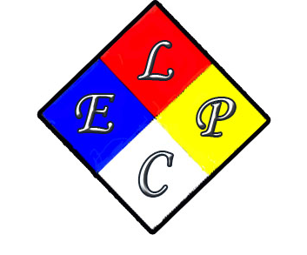

AGENDA

LEPC Quarterly Meeting
December 2025

