Chicago LEPC

MEeting Notice
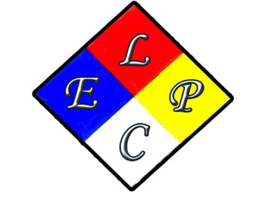 |  | December 16, 2025, Meeting:  Join us for our next quarterly meeting where the discussion topics include:  - Program updates  - Chicago LEPC Exercise Recap  - Committee Nominations  - Other?  A finalized agenda to be sent prior to meeting
December 16, 2025 10:00 AM
Chicago Office of Emergency Management and Communications (OEMC) Room TBD
1411 W. Madison, Chicago IL 60607

